EX No:1A | SETTING UP PYTHON ENVIRONMENT AND LIBRARIES – JUPYTER NOTEBOOK

Aim:

To install Python, configure Jupyter Notebook, understand the notebook environment, execute Python programs, create Markdown cells, and use basic Jupyter Notebook features for Data Analytics applications.

Algorithm:
Algorithm 1: Installing Python
- Download Python from python.org
- Run the installer
- Select "Add Python to PATH"
- Click Install Now
- Verify installation using: python --version
- Observe installed Python version

Algorithm 2: Installing Jupyter Notebook
- Open Command Prompt
- Install Jupyter pip install notebook
- Launch Jupyter Notebook jupyter notebook
- Browser automatically opens Notebook Dashboard.

Algorithm 3: Creating a Notebook
- Open Jupyter Dashboard
- Select New → Python 3
- Create Notebook
- Rename Notebook
- Create Code and Markdown Cells
- Execute cells using Shift + Enter

Program:
Program 1 — Simple Python Program print("Welcome to Data Analytics Lab") Output: Welcome to Data Analytics Lab

Program 2 — Arithmetic Operations
a = 20
b = 10
print("Addition =", a + b) print("Subtraction =", a - b) print("Multiplication =", a * b) print("Division
=", a / b) Output:
Addition = 30
Subtraction = 10
Multiplication = 200
Division = 2.0

Program 3 — Display Student Details
name = "John" dept = "AI&DS"
cgpa = 8.9 print("Name:", name)

print("Department:", dept) print("CGPA:", cgpa) Output:
Name: John Department:
AI&DS CGPA:
8.9

Program 4 — Creating Markdown Cell

Data Analytics Lab ## Experiment 1 ### Jupyter
Notebook Then press
Shift + Enter.

Program 5 — Using NumPy Library
import numpy as np
a = np.array([10, 20, 30, 40, 50])
print(a)
print("Mean =", np.mean(a))
print("Sum =", np.sum(a))

Output:
[10 20 30 40 50]
Mean = 30.0
Sum = 150

Program 6 — Using Pandas Library
import pandas as pd data = {
'Name': ['John', 'David',
'Alex'], 'Marks': [85, 90, 95]
}
df = pd.DataFrame(data)

Program 7 — Using Matplotlib Library

import matplotlib.pyplot as plt x = [1, 2, 3, 4, 5]
y = [10, 20, 15, 25, 30]
plt.plot(x, y) plt.title("Sample Line Graph") plt.xlabel("X Axis") plt.ylabel("Y
Axis") plt.show()

Output:
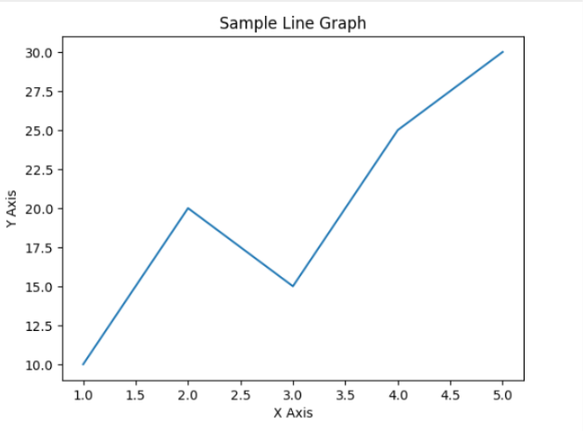

Result:

EXPT NO:1B | SPOTIFY TRACKS SYSTEM USING MACHINE LEARNING

AIM:
To perform Exploratory Data Analysis (EDA) on the Global YouTube Statistics dataset by examining its structure, dimensions, data types, statistical characteristics, missing values, country-wise and channel-type distributions, correlations among numerical attributes, and exporting the dataset into different file formats.

PROCEDURE:
- Import the required libraries such as Pandas, OS, and Matplotlib.
- Load the Global YouTube Statistics CSV dataset using Pandas.
- Display the dataset shape, column names, and data types.
- Display the first five and last five records.
- Generate descriptive statistical information for numerical attributes.
- Identify the number of missing values in each column.
- Find the top 10 countries based on the number of YouTube channels.
- Analyze the distribution of different channel types.
- Analyze the distribution of YouTube categories.
- Display the unique channel types available in the dataset.
- Generate the correlation matrix for numerical attributes.
- Export the dataset into CSV, Excel, and JSON formats.

- Display a confirmation message after successful file creation.

CODE:
import os
import pandas as pd
import matplotlib.pyplot as plt # Load dataset
file_path = "Global YouTube Statistics.csv" df = pd.read_csv(file_path, encoding="latin1") print("Dataset loaded successfully!")
# First 5 records print("\nFirst 5 rows:") display(df.head())
# Last 5 records print("\nLast 5 rows:") display(df.tail())
# Dataset information print("\nDataset Information:") df.info()
# Missing values print("\nMissing Values:") display(df.isnull().sum()) # Top 10 countries
print("\nTop 10 Countries:") display(df["Country"].value_counts().head(10)) # Channel types
print("\nChannel Types:")

display(df["channel_type"].value_counts()) # Categories
print("\nCategories:") display(df["category"].value_counts().head(10)) # Unique channel types
print("\nUnique Channel Types:") print(df["channel_type"].unique()) # Correlation
print("\nCorrelation Matrix:") display(df.corr(numeric_only=True)) # Export files
df.to_csv("youtube_statistics.csv", index=False) df.to_excel("youtube_statistics.xlsx", index=False) df.to_json("youtube_statistics.json", orient="records", indent=4)

print("\nCSV, Excel and JSON files created successfully.")

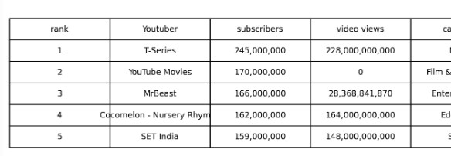
OUTPUT:
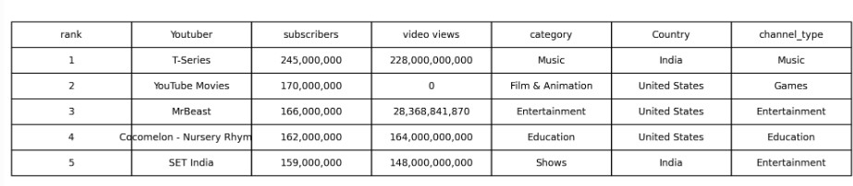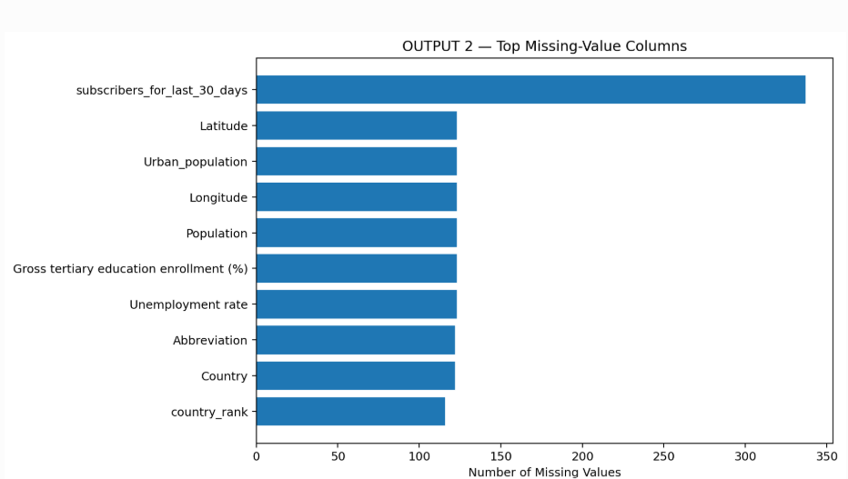

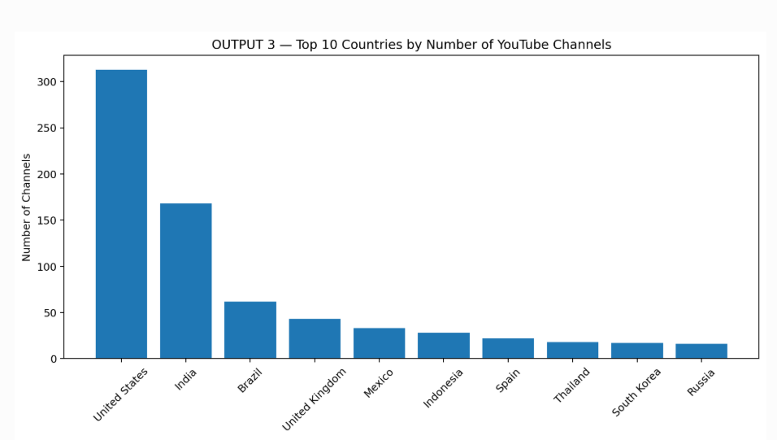

Analysis completed successfully!

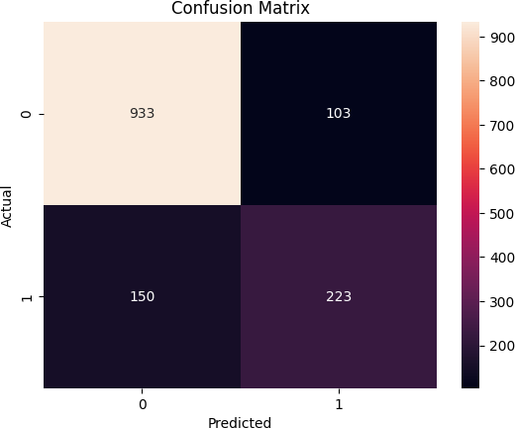

Result:

